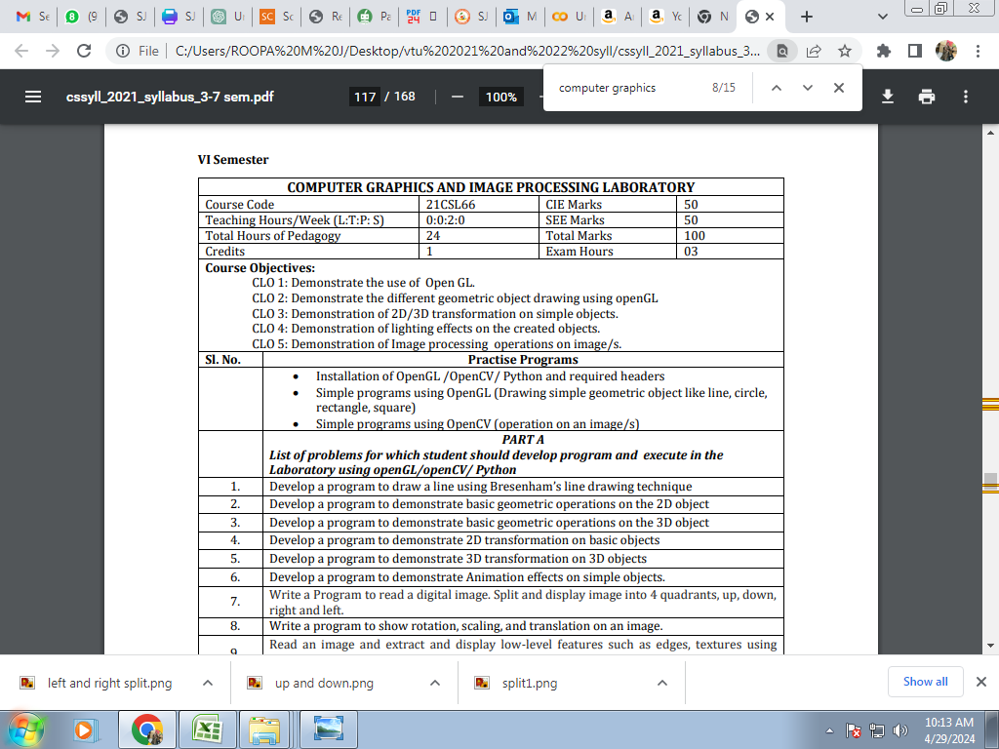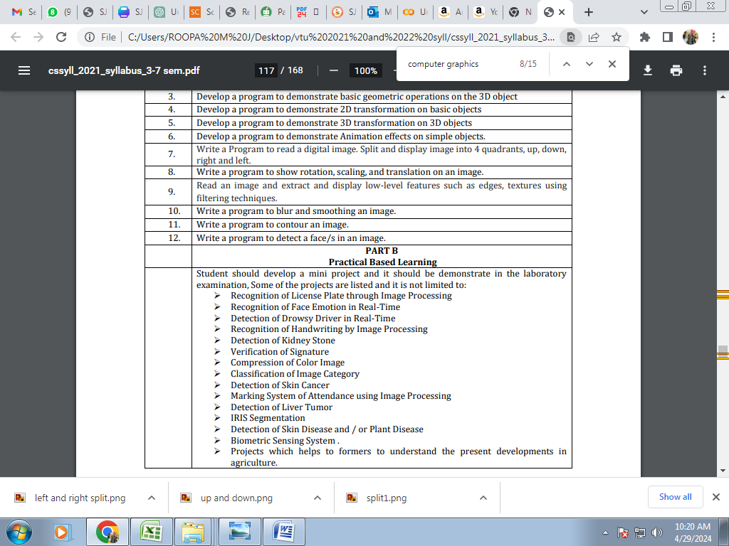

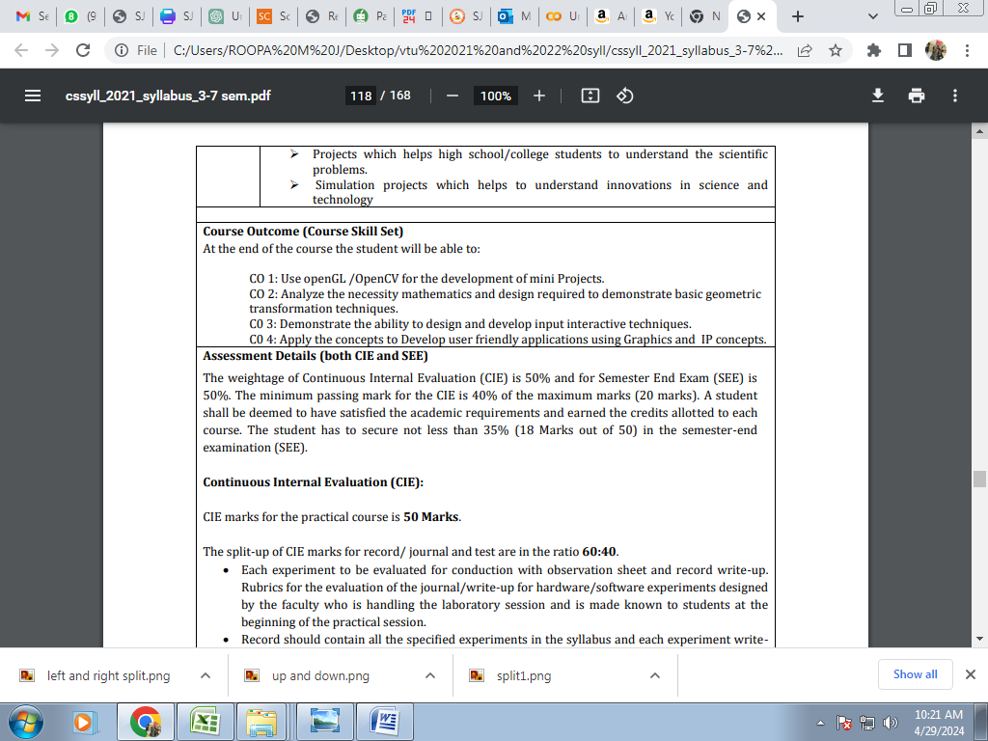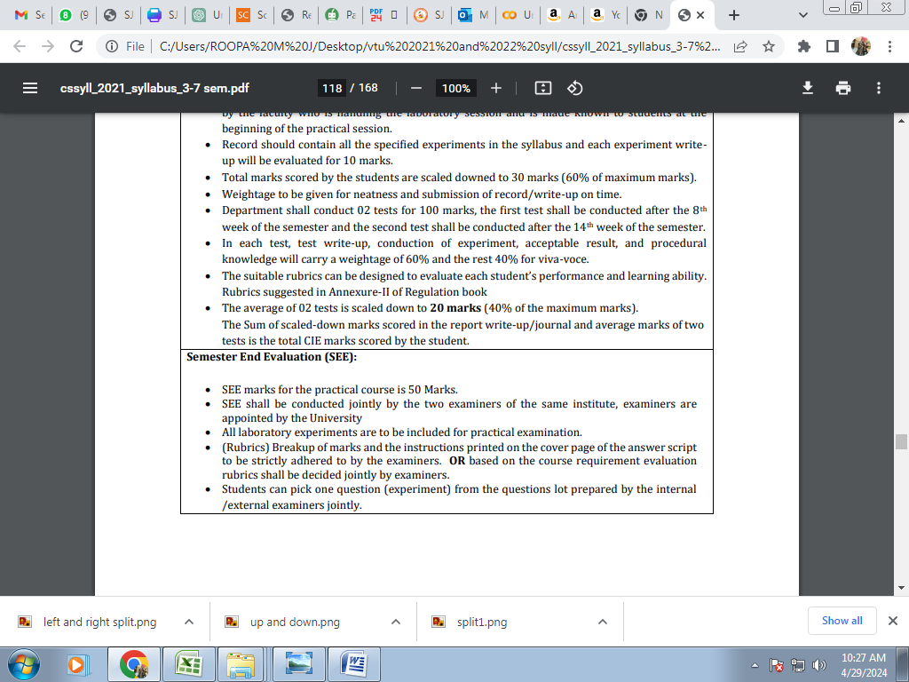

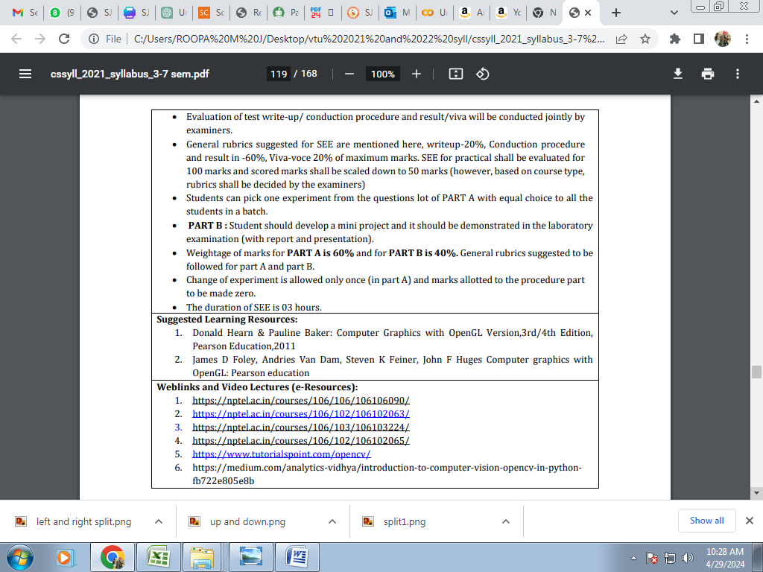

## 7. Write a Program to read a digital image. Split and display image into 4 quadrants, up, down, right and left.

import cv2

import numpy as np

# Read the image

img = cv2.imread(image_pat)

# Get the height and width of the image

height, width = img.shape[:2]

# Split the image into four quadrants

quad1 = img[:height//2, :width//2]

quad2 = img[:height//2, width//2:]

quad3 = img[height//2:, :width//2]

quad4 = img[height//2:, width//2:]

plt.figure(figsize=(10, 5))

plt.subplot(1, 2, 1)

plt.imshow(quad1)

plt.title("1")

plt.axis("off")

plt.subplot(1, 2, 2)

plt.imshow(quad2)

plt.title("2")

plt.axis("off")

plt.figure(figsize=(10, 5))

plt.subplot(1, 2, 1)

plt.imshow(quad3)

plt.title("3")

plt.axis("off")

plt.subplot(1, 2, 2)

plt.imshow(quad4)

plt.title("4")

plt.axis("off")

plt.show()

**output**

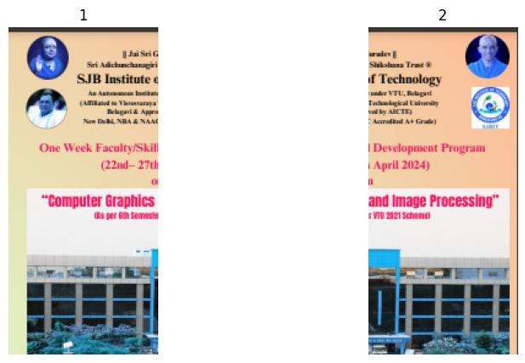

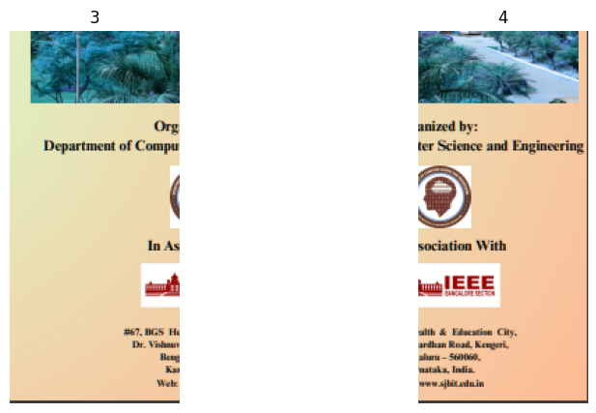

## Additional pgm

# Up- down

import cv2

import numpy as np

# Read the image

img = cv2.imread(image_path)

# Get the height and width of the image

height, width = img.shape[:2]

up = img[:height//2,:]

down = img[height//2:,:]

plt.figure(figsize=(10, 5))

plt.subplot(1, 2, 1)

plt.imshow(up)

plt.title("Up")

plt.axis("off")

plt.subplot(1, 2, 2)

plt.imshow(down)

plt.title("down")

plt.axis("off")

plt.show()

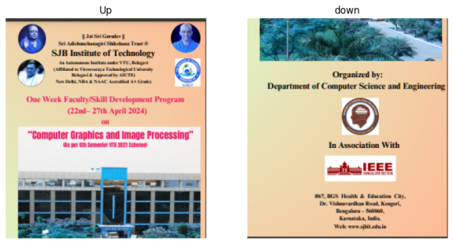

# left- right

import cv2

import numpy as np

# Read the image

img = cv2.imread('/content/3.PNG')

# Get the height and width of the image

height, width = img.shape[:2]

left = img[:, :width//2]

right = img[:, width//2:]

up = img[:height//2,:]

down = img[height//2:,:]

quad1 = img[:height//2, :width//2]

quad2 = img[:height//2, width//2:]

quad3 = img[height//2:, :width//2]

quad4 = img[height//2:, width//2:]

plt.figure(figsize=(10, 5))

plt.subplot(1, 2, 1)

plt.imshow(left)

plt.title("left")

plt.axis("off")

plt.subplot(1, 2, 2)

plt.imshow(right)

plt.title("right")

plt.axis("off")

plt.show()

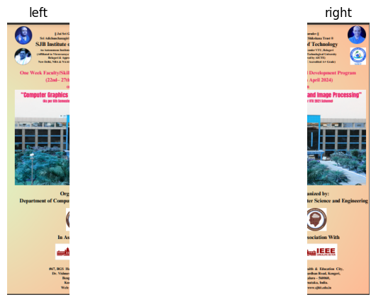

## 8. Write a program to show rotation, scaling, and translation on an image.

#Rotation and scaling of image

import cv2

def translate_image(image, dx, dy):

    rows, cols = image.shape[:2]

    translation_matrix = np.float32([[1, 0, dx], [0, 1, dy]])

    translated_image = cv2.warpAffine(image, translation_matrix, (cols, rows))

    return translated_image

# Read the image

image = cv2.imread('/content/sample_data/3.png')

# Get image dimensions

height, width = image.shape[:2]

# Calculate the center coordinates of the image

center = (width // 2, height // 2)

rotation_value = int(input("Enter the degree of Rotation:"))

scaling_value = int(input("Enter the zooming factor:"))

# Create the 2D rotation matrix

rotated = cv2.getRotationMatrix2D(center=center, angle=rotation_value, scale=1)

rotated_image = cv2.warpAffine(src=image, M=rotated, dsize=(width, height))

scaled = cv2.getRotationMatrix2D(center=center, angle=0, scale=scaling_value)

scaled_image = cv2.warpAffine(src=rotated_image, M=scaled, dsize=(width, height))

h = int(input("How many pixels you want the image to be translated horizontally? "))

v = int(input("How many pixels you want the image to be translated vertically? "))

translated_image = translate_image(scaled_image, dx=h, dy=v)

cv2.imwrite('Final_image.png', translated_image)

## 9. Read an image and extract and display low-level features such as edges, textures using filtering techniques.

import cv2

import numpy as np

# Load the image

image_path = "image/atc.jpg" # Replace with the path to your image

img = cv2.imread(image_path)

# Convert the image to grayscale

gray = cv2.cvtColor(img, cv2.COLOR_BGR2GRAY)

# Edge detection

edges = cv2.Canny(gray, 100, 200) # Use Canny edge detector

# Texture extraction

kernel = np.ones((5, 5), np.float32) / 25 # Define a 5x5 averaging kernel

texture = cv2.filter2D(gray, -1, kernel) # Apply the averaging filter for texture extraction

# Display the original image, edges, and texture

cv2.imshow("Original Image", img)

cv2.imshow("Edges", edges)

cv2.imshow("Texture", texture)

# Wait for a key press and then close all windows

cv2.waitKey(0)

cv2.destroyAllWindows()

**Output**

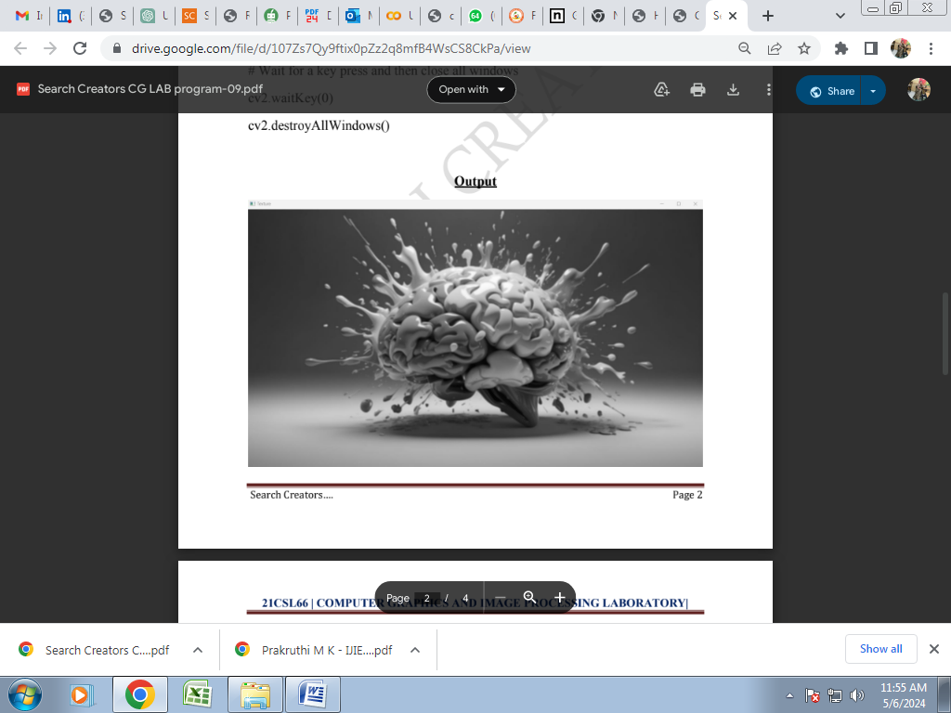

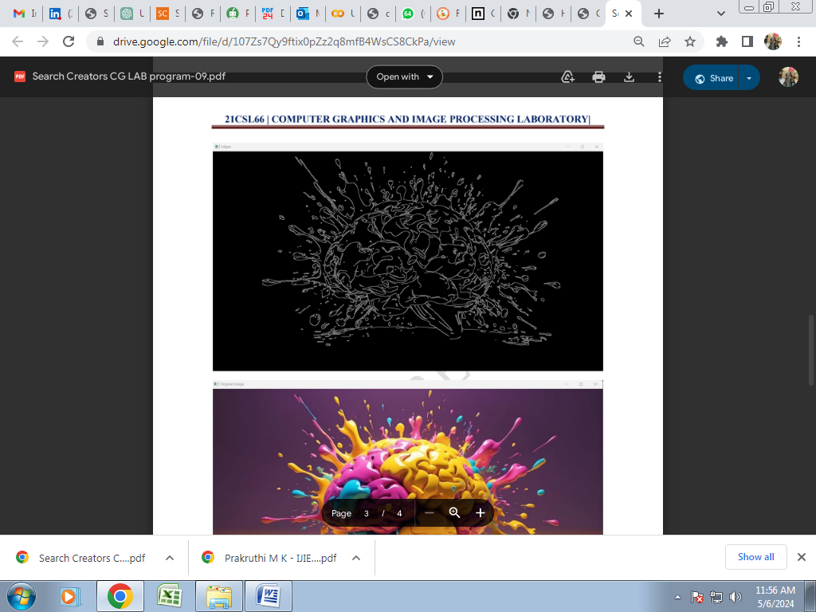

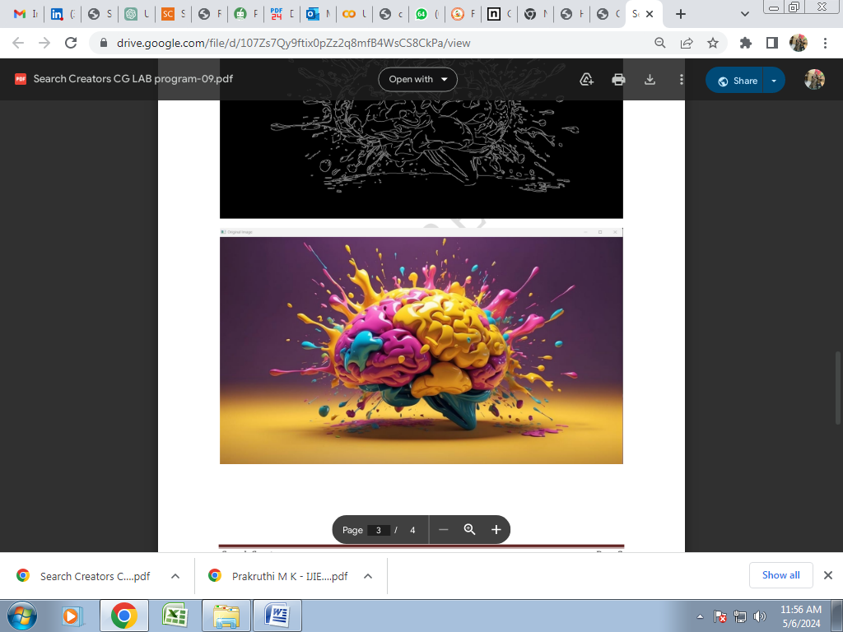

## 10. Write a program to blur and smoothing an image.

img = cv2.imread("/content/sample_data/smaple.jpg",cv2.IMREAD_GRAYSCALE)

image_array = np.array(img)

print(image_array)

def sharpen():

return np.array([[1,1,1],[1,1,1],[1,1,1]])

def filtering(image, kernel):

m, n = kernel.shape

if (m == n):

y, x = image.shape

y = y - m + 1 # shape of image - shape of kernel + 1

x = x - m + 1

new_image = np.zeros((y,x))

for i in range(y):

for j in range(x):

new_image[i][j] = np.sum(image[i:i+m, j:j+m]*kernel)

return new_image

# Display the original and sharpened images

plt.figure(figsize=(10, 5))

plt.subplot(1, 2, 1)

plt.imshow(image_array,cmap='gray')

plt.title("Original Grayscale Image")

plt.axis("off")

plt.subplot(1, 2, 2)

plt.imshow(filtering(image_array, sharpen()),cmap='gray')

plt.title("Blurred Image")

plt.axis("off")

plt.show()

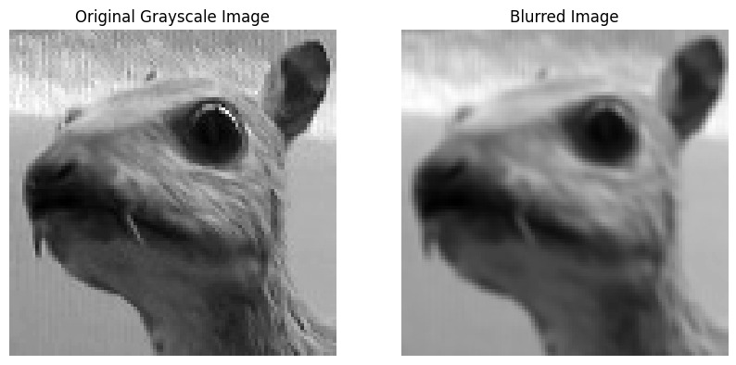

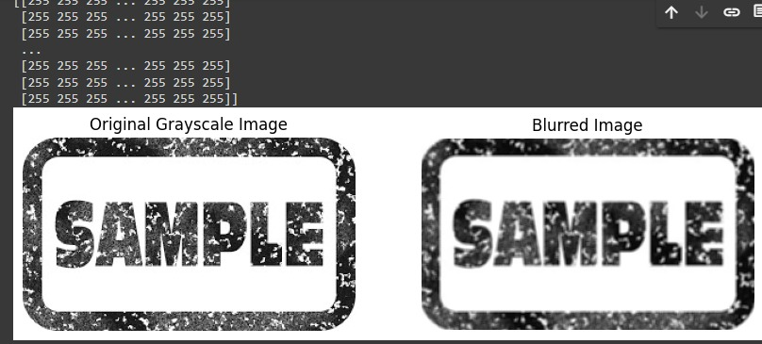

**Extra programs:**

1. #blur

import cv2

# Read the input image (replace 'your_image.jpg' with the actual image path)

image_path = '1.png'

image = cv2.imread(image_path)

# Apply average blur (simple box filter)

average_blur = cv2.blur(image, (5, 5)) # Adjust the kernel size as needed

# Apply Gaussian blur

gaussian_blur = cv2.GaussianBlur(image, (5, 5), 0) # Adjust the kernel size and sigma as needed

# Display the results

cv2.imshow('Original Image', image)

cv2.waitKey(0)

cv2.imshow('Average Blurred Image', average_blur)

cv2.waitKey(0)

cv2.imshow('Gaussian Blurred Image', gaussian_blur)

cv2.waitKey(0)

cv2.destroyAllWindows()

## 11. Write a program to contour an image.

import cv2

import numpy as np

image_path = '1.png'

image = cv2.imread(image_path)

# Convert the image to grayscale (contours work best on binary images)

gray = cv2.cvtColor(image, cv2.COLOR_BGR2GRAY)

# Apply thresholding (you can use other techniques like Sobel edges)

_, binary_image = cv2.threshold(gray, 127, 255, cv2.THRESH_BINARY)

# Find contours

contours, _ = cv2.findContours(binary_image, cv2.RETR_EXTERNAL, cv2.CHAIN_APPROX_SIMPLE)

# Draw all contours on the original image

cv2.drawContours(image, contours, -1, (0, 255, 0), 3)

# Display the result

cv2.imshow('Contours', image)

cv2.waitKey(0)

cv2.destroyAllWindows()

## output

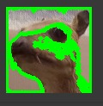

## 12. Write a program to detect a face/s in an image.

import cv2

# Load the pre-trained Haar Cascade classifier for face detection

face_cascade = cv2.CascadeClassifier(cv2.data.haarcascades + 'haarcascade_frontalface_default.xml')

eye_cascade = cv2.CascadeClassifier(cv2.data.haarcascades + 'haarcascade_eye.xml')

# Read the input image (replace 'your_image.jpg' with the actual image path)

image_path = 'face.jpeg'

image = cv2.imread(image_path)

# Convert the image to grayscale

gray = cv2.cvtColor(image, cv2.COLOR_BGR2GRAY)

# Detect faces in the image

faces = face_cascade.detectMultiScale(gray, scaleFactor=1.3, minNeighbors=5)

# Draw rectangles around detected faces

for (x, y, w, h) in faces:

cv2.rectangle(image, (x, y), (x + w, y + h), (255, 0, 0), 2)

# Save or display the result

cv2.imwrite('detected_faces.jpg', image) # Save the result

cv2.imshow('Detected Faces', image) # Display the result

cv2.waitKey(0)

cv2.destroyAllWindows()

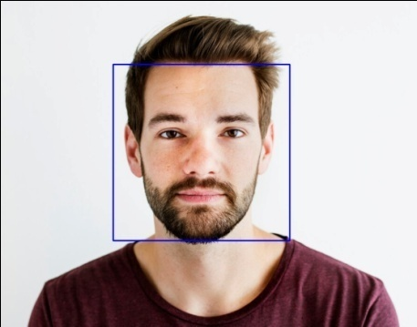

1. another one

import cv2

import matplotlib.pyplot as plt

from IPython.display import display, clear_output

# Initialize the webcam

video_capture = cv2.VideoCapture(0)

while True:

# Capture frame-by-frame

ret, frame = video_capture.read()

# Perform face detection (you can use any pre-trained face detection model)

# For example, using Haar Cascade classifier:

face_cascade = cv2.CascadeClassifier(cv2.data.haarcascades + 'haarcascade_frontalface_default.xml')

faces = face_cascade.detectMultiScale(frame, scaleFactor=1.1, minNeighbors=5, minSize=(30, 30))

# Draw rectangles around detected faces

for (x, y, w, h) in faces:

cv2.rectangle(frame, (x, y), (x + w, y + h), (0, 255, 0), 2)

# Display the frame in the notebook

plt.imshow(cv2.cvtColor(frame, cv2.COLOR_BGR2RGB))

plt.axis('off')

plt.show()

clear_output(wait=True)

# Press 'q' to exit the loop

if cv2.waitKey(0) & 0xFF == ord('q'):

break

# Release the webcam

video_capture.release()

cv2.destroyAllWindows()

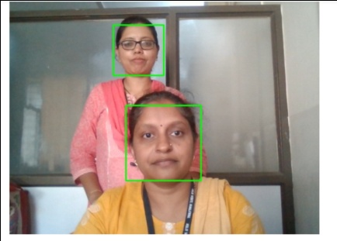

#face detection with emotions

import cv2

from deepface import DeepFace

# Read an image (replace 'your_image.jpg' with the actual image path)

image_path = 'Angry.jpg'

image = cv2.imread(image_path)

# Detect faces in the image

faces = cv2.CascadeClassifier(cv2.data.haarcascades + 'haarcascade_frontalface_default.xml').detectMultiScale(image, scaleFactor=1.1, minNeighbors=5)

# Predict emotions for each detected face

for (x, y, w, h) in faces:

face_roi = image[y:y + h, x:x + w]

result = DeepFace.analyze(face_roi)

emotion = result[0]['emotion']

emotion = dict(sorted(emotion.items(), key=lambda item: item[1]))

emotion = (list(emotion.keys())[-1])

cv2.putText(image, emotion, (x, y - 10), cv2.FONT_HERSHEY_SIMPLEX, 0.5, (0, 255, 0), 2)

cv2.rectangle(image, (x, y), (x + w, y + h), (0, 255, 0), 2)

# Save or display the result

cv2.imwrite('emotion_detected.jpg', image) # Save the result

cv2.imshow('Emotion Detection', image) # Display the result

cv2.waitKey(0)

cv2.destroyAllWindows()

## output

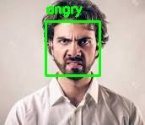

## Extra programs in IP

1. import cv2

# Read the input image

image = cv2.imread(image_pat)

# Flip the image horizontally

flipped_image = cv2.flip(image,-1 )

# Save the flipped image

cv2.imwrite('flipped_image.png', flipped_image)

**output**

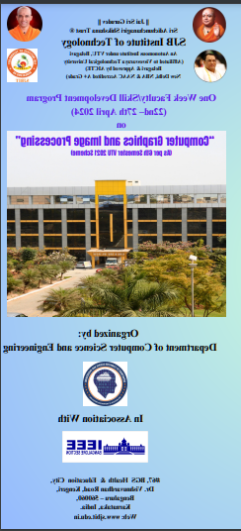

flipped_image = cv2.flip(image,1 )

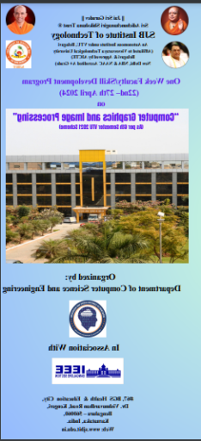

flipped_image = cv2.flip(image,0 )

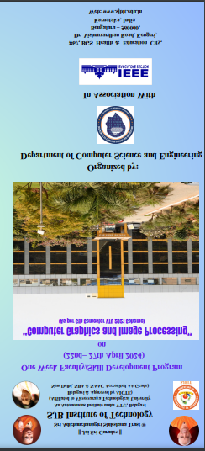

2. # Thresholding

import cv2

import numpy as np

import matplotlib.pyplot as plt

%matplotlib inline

#here 0 means that the image is loaded in gray scale format

gray_image = cv2.imread('/content/3.PNG',0)

ret,thresh_binary = cv2.threshold(gray_image,127,255,cv2.THRESH_BINARY)

ret,thresh_binary_inv = cv2.threshold(gray_image,127,255,cv2.THRESH_BINARY_INV)

ret,thresh_trunc = cv2.threshold(gray_image,127,255,cv2.THRESH_TRUNC)

ret,thresh_tozero = cv2.threshold(gray_image,127,255,cv2.THRESH_TOZERO)

ret,thresh_tozero_inv = cv2.threshold(gray_image,127,255,cv2.THRESH_TOZERO_INV)

#DISPLAYING THE DIFFERENT THRESHOLDING STYLES

names = ['Oiriginal Image','BINARY','THRESH_BINARY_INV','THRESH_TRUNC','THRESH_TOZERO','THRESH_TOZERO_INV']

images = gray_image,thresh_binary,thresh_binary_inv,thresh_trunc,thresh_tozero,thresh_tozero_inv

for i in range(6):

    plt.subplot(2,3,i+1),plt.imshow(images[i],'gray')

    plt.title(names[i])

    plt.xticks([]),plt.yticks([])

plt.show()

output

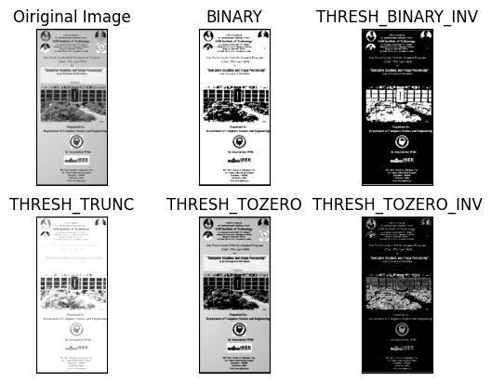

**Extra Pgms to run in google colab**

Pgm1:

img = cv2.imread("/content/sample_data/1.png",cv2.IMREAD_GRAYSCALE)

image_array = np.array(img)

print(image_array)

def sharpen():

  return np.array([

[0,-1,0],[-1,5,-1],[0,-1,0]

  ])

def filtering(image, kernel):

    m, n = kernel.shape

    if (m == n):

        y, x = image.shape

        y = y - m + 1 # shape of image - shape of kernel + 1

        x = x - m + 1

        new_image = np.zeros((y,x))

        for i in range(y):

            for j in range(x):

                new_image[i][j] = np.sum(image[i:i+m, j:j+m]*kernel)

    return new_image

# Display the original and sharpened images

plt.figure(figsize=(10, 5))

plt.subplot(1, 2, 1)

plt.imshow(image_array,cmap='gray')

plt.title("Original Grayscale Image")

plt.axis("off")

plt.subplot(1, 2, 2)

plt.imshow(filtering(image_array, sharpen()),cmap='gray')

plt.title("Blurred Image")

plt.axis("off")

plt.show()

"""# New Section"""

Pgm2:

import numpy as np

import cv2

import matplotlib.pyplot as plt

from google.colab.patches import cv2_imshow

img = cv2.imread("C:\Users\HP-PC\Pictures\smaple.jpg")

image_array = np.array(img)

def rgb2gray(image):

    return np.dot(image[..., :3], [0.2989, 0.5870, 0.1140])

grayscale_image = rgb2gray(image_array)

print(image_array.shape)

plt.figure(figsize=(10, 5))

plt.subplot(1, 2, 1)

plt.imshow(image_array)

plt.title("Original  Image")

plt.axis("off")

plt.subplot(1, 2, 2)

plt.imshow(grayscale_image,cmap='gray')

plt.title("Grayscale Image")

plt.axis("off")

plt.show()

grayscale_image[24,8]

def sharpen():

  return np.array([

[0,-1,0],[-1,5,-1],[0,-1,0]

  ])

def filtering(image, kernel):

    m, n = kernel.shape

    if (m == n):

        y, x = image.shape

        y = y - m + 1 # shape of image - shape of kernel + 1

        x = x - m + 1

        new_image = np.zeros((y,x))

        for i in range(y):

            for j in range(x):

                new_image[i][j] = np.sum(image[i:i+m, j:j+m]*kernel)

    return

plt.figure(figsize=(10, 5))

plt.subplot(1, 2, 1)

plt.imshow(image_array, cmap='gray')

plt.title("Original  Image")

plt.axis("off")

plt.subplot(1, 2, 2)

plt.imshow(filtering(grayscale_image,sharpen()),cmap='gray')

plt.title("Sharpen Image")

plt.axis("off")

plt.show()

pgm3:

#Color image to Gray image

import numpy as np

import cv2

import matplotlib.pyplot as plt

def rgb2gray(image):

    return np.dot(image[..., :3], [0.2989, 0.5870, 0.1140])

    filename = '1.png'

image = cv2.imread("/content/sample_data/JS pp photo.jpg")

image_array = np.array(image)

grayscale_image = rgb2gray(image_array)

print(image_array.shape)

plt.figure(figsize=(10, 5))

plt.subplot(1, 2, 1)

plt.imshow(image_array)

plt.title("Original  Image")

plt.axis("off")

plt.subplot(1, 2, 2)

plt.imshow(grayscale_image,cmap='gray')

plt.title("Grayscale Image")

plt.axis("off")

plt.show()

pgm4:

#Rotating an image

filename = '/content/sample_data/JS pp photo.jpg'

image = cv2.imread(filename,cv2.IMREAD_UNCHANGED)

image_array = np.array(image)

def get_rotation(angle):

    angle = np.radians(angle)

    return np.array([

[np.cos(angle), -np.sin(angle), 0],

[np.sin(angle), np.cos(angle), 0],

[0, 0, 1]

])

img_transformed = np.zeros((400,400,3), dtype=np.uint8)

R1 = get_rotation(45)

for i, row in enumerate(image_array):

    for j, col in enumerate(row):

        pixel_data = image_array[i, j, :]

        input_coords = np.array([i, j,1])

        i_out, j_out, _ = (R1 @ input_coords).astype(int)

        img_transformed[i_out+150,j_out, :] = pixel_data

plt.figure(figsize=(10, 5))

plt.subplot(1, 2, 1)

plt.imshow(image_array)

plt.title("Original Grayscale Image")

plt.axis("off")

plt.subplot(1, 2, 2)

plt.imshow(img_transformed)

plt.title("Rotated Image")

plt.axis("off")

plt.show()

cv2.imwrite('/content/sample_data/rotate.jpg',img_transformed)

pgm5:

import cv2

from google.colab.patches import cv2_imshow

img  = cv2.imread('/content/sample_data/Colors.jpg',-1)

cv2_imshow(img)

cv2.waitKey(0)

cv2.destroyAllWindows()

#prgm-8

image = cv2.imread('/content/sample_data/Rainbow.jpg',1)

B, G, R = cv2.split(image)

# Corresponding channels are separated

cv2_imshow(image)

cv2.waitKey(0)

cv2_imshow(B)

cv2.waitKey(0)

cv2_imshow(G)

cv2.waitKey(0)

cv2_imshow(R)

cv2.waitKey(0)

cv2.destroyAllWindows()

Pgm6:

import cv2

from google.colab.patches import cv2_imshow

img1 = cv2.imread("/content/sample_data/do_not_copy.png")

#img1=cv2.imread("")

print(img1.shape)

img2 = cv2.imread("/content/sample_data/3.png")

img2 = cv2.resize(img2,(224,225))

print(img2.shape)

final_img = cv2.addWeighted(img2,1,img1,0.7,0)

cv2_imshow(final_img)

cv2.imwrite('/content/sample_data/rgbchannels.jpg',image)

filename = '/content/sample_data/smaple.jpg'

image = cv2.imread(filename,cv2.IMREAD_GRAYSCALE)

image_array = np.array(image)

def sharpen():

    return np.array([

[0,-1, 0],

[-1,10, -1],

[0,-1, 0]

])

def filtering(image, kernel):

    m, n = kernel.shape

    if (m == n):

        y, x = image.shape

        y = y - m + 1 # shape of image - shape of kernel + 1

        x = x - m + 1

        new_image = np.zeros((y,x))

        for i in range(y):

            for j in range(x):

                new_image[i][j] = np.sum(image[i:i+m, j:j+m]*kernel)

    return new_image

# Display the original and sharpened images

plt.figure(figsize=(10, 5))

plt.subplot(1, 2, 1)

plt.imshow(image_array, cmap='gray')

plt.title("Original Grayscale Image")

plt.axis("off")

plt.subplot(1, 2, 2)

plt.imshow(filtering(image_array, sharpen()),cmap='gray')

plt.title("Sharpened Image")

plt.axis("off")

plt.show()

pgm7:

img = cv2.imread("/content/sample_data/smaple.jpg",cv2.IMREAD_GRAYSCALE)

image_array = np.array(img)

print(image_array)

def sharpen():

  return np.array([

[1/9,1/9,1/9],[1/9,1/9,1/9],[1/9,1/9,1/9]

  ])

def filtering(image, kernel):

    m, n = kernel.shape

    if (m == n):

        y, x = image.shape

        y = y - m + 1 # shape of image - shape of kernel + 1

        x = x - m + 1

        new_image = np.zeros((y,x))

        for i in range(y):

            for j in range(x):

                new_image[i][j] = np.sum(image[i:i+m, j:j+m]*kernel)

    return new_image

# Display the original and sharpened images

plt.figure(figsize=(10, 5))

plt.subplot(1, 2, 1)

plt.imshow(image_array,cmap='gray')

plt.title("Original Grayscale Image")

plt.axis("off")

plt.subplot(1, 2, 2)

plt.imshow(filtering(image_array, sharpen()),cmap='gray')

plt.title("Blurred Image")

plt.axis("off")

plt.show()

pgm8:

#Guassian Blur

img = cv2.imread("/content/sample_data/smaple.jpg",cv2.IMREAD_GRAYSCALE)

image_array = np.array(img)

print(image_array)

def sharpen():

  return np.array([

[1/16,2/16,1/16],[2/16,4/16,2/16],[1/16,2/16,1/16]

  ])

def filtering(image, kernel):

    m, n = kernel.shape

    if (m == n):

        y, x = image.shape

        y = y - m + 1 # shape of image - shape of kernel + 1

        x = x - m + 1

        new_image = np.zeros((y,x))

        for i in range(y):

            for j in range(x):

                new_image[i][j] = np.sum(image[i:i+m, j:j+m]*kernel)

    return new_image

# Display the original and sharpened images

plt.figure(figsize=(10, 5))

plt.subplot(1, 2, 1)

plt.imshow(image_array,cmap='gray')

plt.title("Original Grayscale Image")

plt.axis("off")

plt.subplot(1, 2, 2)

plt.imshow(filtering(image_array, sharpen()),cmap='gray')

plt.title("Guassian Blurred Image")

plt.axis("off")

plt.show()

pgm9:

#Ridge Detection

img = cv2.imread("/content/sample_data/JS pp photo.jpg",cv2.IMREAD_GRAYSCALE)

image_array = np.array(img)

print(image_array)

def sharpen():

  return np.array([

[0,-1,0],[-1,0,-1],[0,-1,0]

  ])

def filtering(image, kernel):

    m, n = kernel.shape

    if (m == n):

        y, x = image.shape

        y = y - m + 1 # shape of image - shape of kernel + 1

        x = x - m + 1

        new_image = np.zeros((y,x))

        for i in range(y):

            for j in range(x):

                new_image[i][j] = np.sum(image[i:i+m, j:j+m]*kernel)

    return new_image

# Display the original and sharpened images

plt.figure(figsize=(10, 5))

plt.subplot(1, 2, 1)

plt.imshow(image_array,cmap='gray')

plt.title("Original Grayscale Image")

plt.axis("off")

plt.subplot(1, 2, 2)

plt.imshow(filtering(image_array, sharpen()),cmap='gray')

plt.title("Ridge detection Image")

plt.axis("off")

plt.show()

pgm10:

#Edge Detection

img = cv2.imread("/content/sample_data/JS pp photo.jpg",cv2.IMREAD_GRAYSCALE)

image_array = np.array(img)

print(image_array)

def sharpen():

  return np.array([

[-1,-1,-1],[-1,8,-1],[-1,-1,-1]

  ])

def filtering(image, kernel):

    m, n = kernel.shape

    if (m == n):

        y, x = image.shape

        y = y - m + 1 # shape of image - shape of kernel + 1

        x = x - m + 1

        new_image = np.zeros((y,x))

        for i in range(y):

            for j in range(x):

                new_image[i][j] = np.sum(image[i:i+m, j:j+m]*kernel)

    return new_image

# Display the original and sharpened images

plt.figure(figsize=(10, 5))

plt.subplot(1, 2, 1)

plt.imshow(image_array,cmap='gray')

plt.title("Original Grayscale Image")

plt.axis("off")

plt.subplot(1, 2, 2)

plt.imshow(filtering(image_array, sharpen()),cmap='gray')

plt.title("edge detection Image")

plt.axis("off")

plt.show()

pgm11:

# comment

import cv2

from google.colab.patches import cv2_imshow

image = cv2.imread('/content/3.png',1)

B, G, R = cv2.split(image)

# Corresponding channels are separated

cv2_imshow(image)

cv2.waitKey(0)

cv2_imshow(B)

cv2.waitKey(0)

cv2_imshow(G)

cv2.waitKey(0)

cv2_imshow(R)

cv2.waitKey(0)

cv2.destroyAllWindows()

#Image resizing 1

import cv2

from google.colab.patches import cv2_imshow

img1 = cv2.imread("/content/sample_data/do_not_copy.png")

print(img1.shape)

img2 = cv2.imread("/content/sample_data/3.png")

img2 = cv2.resize(img2,(224,225))

print(img2.shape)

final_img = cv2.addWeighted(img2,1,img1,0.7,0)

cv2_imshow(final_img)

#cv2.waitKey(0)

#cv2.destroyAllWindows()

#Image resizing 2

import cv2

from google.colab.patches import cv2_imshow

img1 = cv2.imread("/content/sample_data/circle.png")

#img1=cv2.imread("")

print(img1.shape)

img2 = cv2.imread("/content/sample_data/square.png")

img2 = cv2.resize(img2,(img1.shape[1],img1.shape[0]))

print(img2.shape)

final_img = cv2.addWeighted(img1,0.7,img2,0.6,0)

cv2_imshow(final_img)

#Image subtraction

import cv2

from google.colab.patches import cv2_imshow

img_1 = cv2.imread('/content/sample_data/square.png')

print(img_1.shape)

img_2 = cv2.imread('/content/sample_data/circle.png')

print(img_2.shape)

final_img = cv2.subtract(img_2,img_1)

cv2_imshow(final_img)

cv2.waitKey(0)

cv2.destroyAllWindows()

#Image subtraction for gray images

img_1 = cv2.imread('/content/sample_data/square.png',0)

img_2 = cv2.imread('/content/sample_data/circle.png',0)

img_2  = cv2.resize(img_2,(img1.shape[1],img_1.shape[0]))

final_img = cv2.subtract(img_2,img_1)

cv2_imshow(final_img)

pgm12:

#Image translation

import cv2

import numpy as np

def translate_image(image, dx, dy):

    rows, cols = image.shape[:2]

    translation_matrix = np.float32([[1, 0, dx], [0, 1, dy]])

    translated_image = cv2.warpAffine(image, translation_matrix, (cols, rows))

    return translated_image

# Read the image

image = cv2.imread('/content/sample_data/circle.png')

# Translate the image by dx=50 pixels and dy=30 pixels

translated_image = translate_image(image, dx=20, dy=30)

# Save the translated image to disk

cv2.imwrite('translated_image.png', translated_image)

pgm13:

import cv2

import numpy as np

def translate_image(image, dx, dy):

    rows, cols = image.shape[:2]

    translation_matrix = np.float32([[1, 0, dx], [0, 1, dy]])

    translated_image = cv2.warpAffine(image, translation_matrix, (cols, rows))

    return translated_image

# Read the image

image = cv2.imread('/content/sample_data/circle.png')

# Translate the image by dx=20 pixels and dy=0 pixels, translate horizontally by 20px

translated_image = translate_image(image, dx=20, dy=0)

# Save the translated image to disk

cv2.imwrite('translated_image.png', translated_image)

pgm14:

#Image Zoom in

import cv2

import numpy as np

# Read the image

image = cv2.imread('//content/sample_data/circle.png')

# Get image dimensions

height, width = image.shape[:2]

# Calculate the center coordinates of the image

center = (width / 2, height / 2)

# Create the 2D rotation matrix

rotate_matrix = cv2.getRotationMatrix2D(center=center, angle=30, scale=2)

# Rotate the image

rotated_image = cv2.warpAffine(src=image, M=rotate_matrix, dsize=(width, height))

# Display the original and rotated images

def translate_image(image, dx, dy):

    rows, cols = image.shape[:2]

    translation_matrix = np.float32([[1, 0, dx], [0, 1, dy]])

    translated_image = cv2.warpAffine(image, translation_matrix, (cols, rows))

    return translated_image

# Read the image

#image = cv2.imread('1.jpg')

# Translate the image by dx=50 pixels and dy=30 pixels

translated_image = translate_image(rotated_image, dx=00, dy=20)

# Save the translated image to disk

cv2.imwrite('translated_image.png', translated_image)

pgm15:

#Rotation and scaling of image

import cv2

def translate_image(image, dx, dy):

    rows, cols = image.shape[:2]

    translation_matrix = np.float32([[1, 0, dx], [0, 1, dy]])

    translated_image = cv2.warpAffine(image, translation_matrix, (cols, rows))

    return translated_image

# Read the image

image = cv2.imread('/content/sample_data/3.png')

# Get image dimensions

height, width = image.shape[:2]

# Calculate the center coordinates of the image

center = (width // 2, height // 2)

rotation_value = int(input("Enter the degree of Rotation:"))

scaling_value = int(input("Enter the zooming factor:"))

# Create the 2D rotation matrix

rotated = cv2.getRotationMatrix2D(center=center, angle=rotation_value, scale=1)

rotated_image = cv2.warpAffine(src=image, M=rotated, dsize=(width, height))

scaled = cv2.getRotationMatrix2D(center=center, angle=0, scale=scaling_value)

scaled_image = cv2.warpAffine(src=rotated_image, M=scaled, dsize=(width, height))

h = int(input("How many pixels you want the image to be translated horizontally? "))

v = int(input("How many pixels you want the image to be translated vertically? "))

translated_image = translate_image(scaled_image, dx=h, dy=v)

cv2.imwrite('Final_image.png', translated_image)

pgm16:

#Splitting an image into 4 equal quadrants

import cv2

import numpy as np

# Read the image

from google.colab.patches import cv2_imshow

img = cv2.imread('/content/sample_data/3.png')

# Get the height and width of the image

height, width = img.shape[:2]

# Split the image into four quadrants

quad1 = img[:height//2, :width//2]

quad2 = img[:height//2, width//2:]

quad3 = img[height//2:, :width//2]

quad4 = img[height//2:, width//2:]

# Display the four quadrants

cv2_imshow(quad1)

cv2_imshow(quad2)

cv2_imshow(quad3)

cv2_imshow(quad4)

pgm17:

# Commented out IPython magic to ensure Python compatibility.

#displaying an Image with different levels of thresholds

import cv2

import numpy as np

import matplotlib.pyplot as plt

# %matplotlib inline

#here 0 means that the image is loaded in gray scale format

gray_image = cv2.imread('/content/sample_data/3.png',0)

ret,thresh_binary = cv2.threshold(gray_image,127,255,cv2.THRESH_BINARY)

ret,thresh_binary_inv = cv2.threshold(gray_image,127,255,cv2.THRESH_BINARY_INV)

ret,thresh_trunc = cv2.threshold(gray_image,127,255,cv2.THRESH_TRUNC)

ret,thresh_tozero = cv2.threshold(gray_image,127,255,cv2.THRESH_TOZERO)

ret,thresh_tozero_inv = cv2.threshold(gray_image,127,255,cv2.THRESH_TOZERO_INV)

#DISPLAYING THE DIFFERENT THRESHOLDING STYLES

names = ['Oiriginal Image','BINARY','THRESH_BINARY_INV','THRESH_TRUNC','THRESH_TOZERO','THRESH_TOZERO_INV']

images = gray_image,thresh_binary,thresh_binary_inv,thresh_trunc,thresh_tozero,thresh_tozero_inv

for i in range(6):

    plt.subplot(2,3,i+1),plt.imshow(images[i],'gray')

    plt.title(names[i])

    plt.xticks([]),plt.yticks([])

plt.show()

pgm17:

#Zooming out of an image

import cv2

from google.colab.patches import cv2_imshow

# Read the input image

original_image = cv2.imread('/content/sample_data/3.png')

# Zoom out (reduce size by half)

zoomed_out_image = cv2.pyrDown(original_image)

# Display the original and zoomed-out images

cv2_imshow(original_image)

cv2_imshow(zoomed_out_image)

cv2.waitKey(0)

cv2.destroyAllWindows()

pgm18:

import cv2

import numpy as np

# Read the image

from google.colab.patches import cv2_imshow

img = cv2.imread('/content/3.png')

# Get the height and width of the image

height, width = img.shape[:2]

# Split the image into four quadrants

quad1 = img[:height//2, :width//2]

quad2 = img[:height//2, width//2:]

quad3 = img[height//2:, :width//2]

quad4 = img[height//2:, width//2:]

# Display the four quadrants

cv2.imshow('quadrant1',quad1)

cv2.imshow('quadrant2',quad2)

cv2.imshow('quadrant3',quad3)

cv2.imshow('quadrant4',quad4)

cv2.imwrite('quad1.png', quad1)

cv2.imwrite('quad2.png', quad2)

cv2.imwrite('quad3.png', quad3)

cv2.imwrite('quad4.png', quad4)

pgm19:

import cv2

import numpy as np

# Read the image

img = cv2.imread('/content/sample_data/3.png')

# Get the height and width of the image

height, width = img.shape[:2]

# Split the image into four quadrants

quad1 = img[:height//2, :width//2]

quad2 = img[:height//2, width//2:]

quad3 = img[height//2:, :width//2]

quad4 = img[height//2:, width//2:]

plt.figure(figsize=(10, 5))

plt.subplot(1, 2, 1)

plt.imshow(quad1)

plt.title("1")

plt.axis("off")

plt.subplot(1, 2, 2)

plt.imshow(quad2)

plt.title("2")

plt.axis("off")

plt.figure(figsize=(10, 5))

plt.subplot(1, 2, 1)

plt.imshow(quad3)

plt.title("3")

plt.axis("off")

plt.subplot(1, 2, 2)

plt.imshow(quad4)

plt.title("4")

plt.axis("off")

plt.show()

pgm20:

# Up- down

import cv2

import numpy as np

# Read the image

img = cv2.imread('/content/3.png')

# Get the height and width of the image

height, width = img.shape[:2]

up = img[:height//2,:]

down = img[height//2:,:]

plt.figure(figsize=(10, 5))

plt.subplot(1, 2, 1)

plt.imshow(up)

plt.title("Up")

plt.axis("off")

plt.subplot(1, 2, 2)

plt.imshow(down)

plt.title("down")

plt.axis("off")

plt.show()

pgm21:

# Up- down

import cv2

import numpy as np

# Read the image

img = cv2.imread('/content/3.png')

# Get the height and width of the image

height, width = img.shape[:2]

up = img[:height//2,:]

down = img[height//2:,:]

plt.figure(figsize=(10, 5))

plt.subplot(2, 1, 1)

plt.imshow(up)

plt.title("Up")

plt.axis("off")

plt.subplot(2, 1, 2)

plt.imshow(down)

plt.title("down")

plt.axis("off")

plt.show()

pgm21:

# left right

import cv2

import numpy as np

# Read the image

img = cv2.imread('/content/sample_data/JS pp photo.jpg')

#height means all rows and

#width means all the columns

# Get the height and width of the image

height, width = img.shape[:2]

left = img[:, :width//2]

right = img[:, width//2:]

up = img[:height//2,:]

down = img[height//2:,:]

plt.figure(figsize=(10, 5))

plt.subplot(2, 1, 1)

plt.imshow(left)

plt.title("Left")

plt.axis("off")

plt.subplot(2, 1, 2)

plt.imshow(right)

plt.title("right")

plt.axis("off")

plt.show()

# Split the image into four quadrants

quad1 = img[:height//2]

quad2 = img[height//2:]

quad3 = img[:, :width//2:]

quad4 = img[:, width//2:]

plt.figure(figsize=(10, 5))

plt.subplot(1, 2, 1)

plt.imshow(quad1)

plt.title("1")

plt.axis("off")

plt.subplot(1, 2, 2)

plt.imshow(quad2)

plt.title("2")

plt.axis("off")

plt.figure(figsize=(5, 10))

plt.subplot(1, 2, 1)

plt.imshow(quad3)

plt.title("3")

plt.axis("off")

plt.subplot(1, 2, 2)

plt.imshow(quad4)

plt.title("4")

plt.axis("off")

plt.show()

pgm22:

import cv2

import numpy as np

image = cv2.imread('/content/sample_data/JS pp photo.jpg')

# Increase the brightness by adding 20 to each pixel value

brightness = 20

# Increase the contrast by scaling the pixel values by 5

contrast = 2

# Apply the brightness and contrast adjustments

image = cv2.addWeighted(image, contrast, np.zeros(image.shape, image.dtype), 0, brightness)

# Save the image

cv2.imwrite('image_brightened_and_contrasted.png', image)